What does ACCII Code mean?

It's obvious that the word "ACCII" refers to an abbreviation, which is American Standard Code for Information Interchange. It's a system that computers use to convert anything you may write such as letters, numbers, punctuation, and symbols into a language that computers can understand .

How ACCII Code works?

ACCII is a fundamental concept in computer science, it doesn't directly interact with programming languages in a complex way. Instead, it serves as a foundational layer that enables programming languages to work with text data.

For example, when you are writing a code and you have initialized char = 'A' , you can change the letter 'A' to 'a' or vice versa by using accii code. Because accii code have the ability to convert any character to a number, by adding 32 to the number to convert the character from capital letter to small letter, and if we have an initialized small letter by using char , accii code can subtract 32 from the number that represent that small character to make a capital letter . But accii code considred as limit because it uses only 7 bits to represent characters, limiting it to 128 characters .This is insufficient for many languages and special characters, leading to its limitations in representing diverse text.

Here we have picture for the letter 'S' that shows to what acci code convert it:

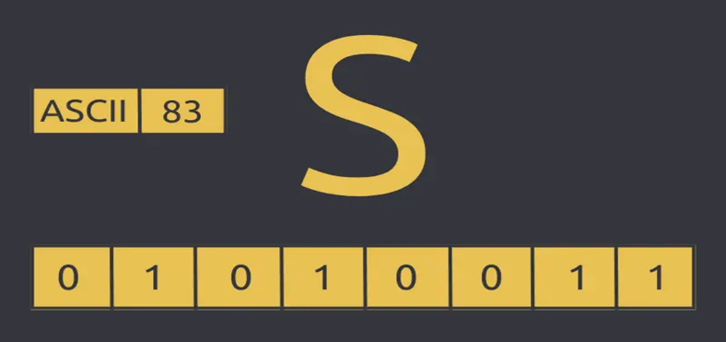

Here is a link for a video about accii code : <https://www.youtube.com/watch?v=zB85kTs-sEw>